**Tree Timeline**



[1]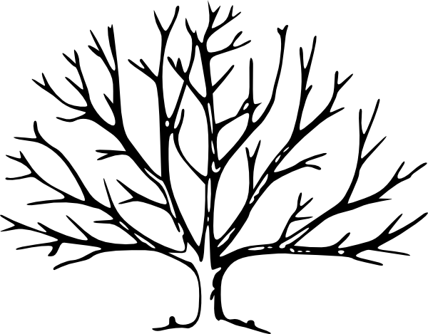

1. *http://www.clker.com/cliparts/P/U/1/q/t/b/tree-with-no-leaves-hi.png*